
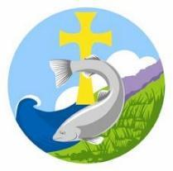

St Hilda’s Moorland Federation
Egton CE (VA) School and Danby CE (VA) School

Pupils Privacy Notice v2

Who are we?


We are your primary school. Our staff helps you to learn, develop, and prepare you for secondary school.

We must look after your personal information. We have a Data Protection Officer called Veritau, who ensures we are keeping your information safe and secure.

If you would like more information, please speak to your teacher or the school office.

What is personal data?


Personal data is information about a specific person. Your name, age and address are all examples of your personal data.

We need to be extra careful with certain types of sensitive personal data. This is called special category data. Medical information we collect when you are ill is an example of this.

What information do we collect about you?

To work properly as a school, we need to collect a lot of information about you. This includes:

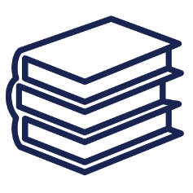
- Your name, where you live, and your date of birth
- Who looks after you outside of school
- Your test results and behaviour in the classroom
- The number of days you have been in school
- School trips and after-school clubs you have attended
- Photos or videos of you

We also collect special category data about your health, religion, and ethnicity.

For the full list of all the information we collect, you can read our main Pupils, Parents, and Guardians Privacy Notice.


Why do we collect information about you?

We collect your information so we can teach you properly, organise school trips and activities, and keep you safe.

Who do we get your information from?

We get information from you and your family.

There might also be times when a social worker, doctor, the council, or a government department may send us information about you.

Who do we share your information with?

Sometimes, we need to share your information with people outside of the school. For example:

  - Your next school
  - The council
  - Doctors and other people whose job is to help you
  - The Government Department for Education
  - Exam bodies
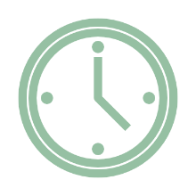
How long do we keep your information?

We keep your information for as long as we need it to teach and support you, or as long as the law tells us to.

What rights do you have?
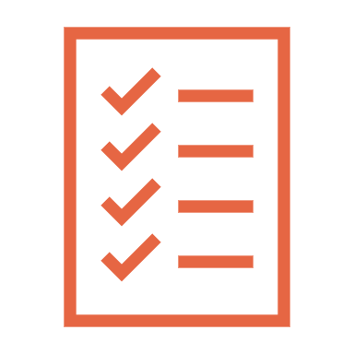
- You can ask for a copy of all the information we hold about you.
- You can ask for information to be corrected if you think it is wrong.
- You can ask for your information to be deleted.

For more information on your rights, please ask the school office.
Document date: 27th January 2026

